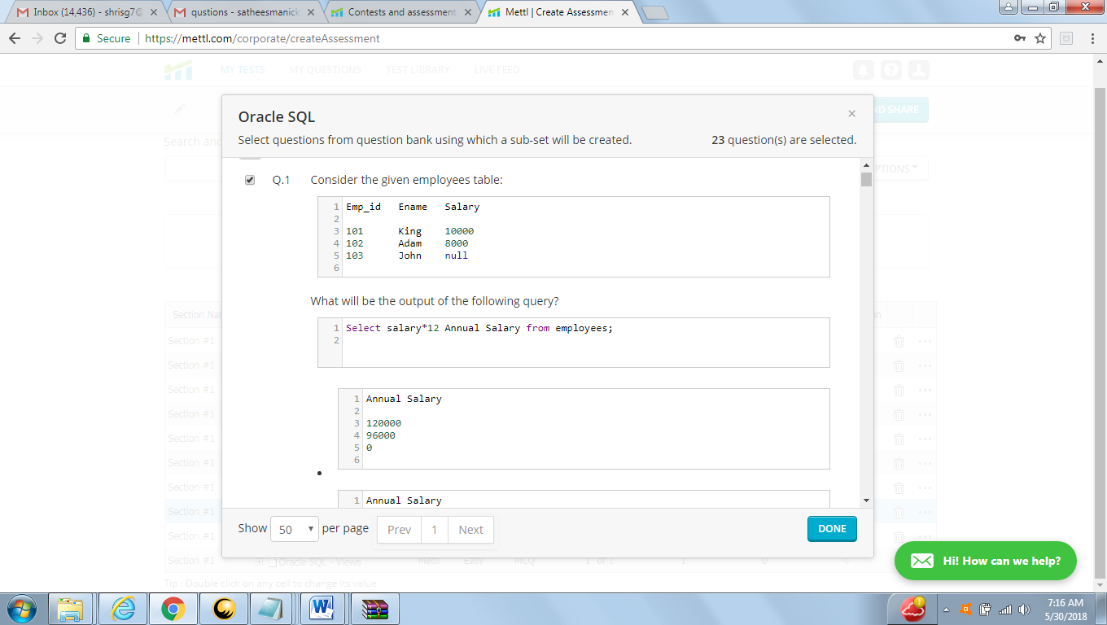

AnSWER :

|  |
| --- |
|  |
| 120000 |
| 96000 |
| *null* |

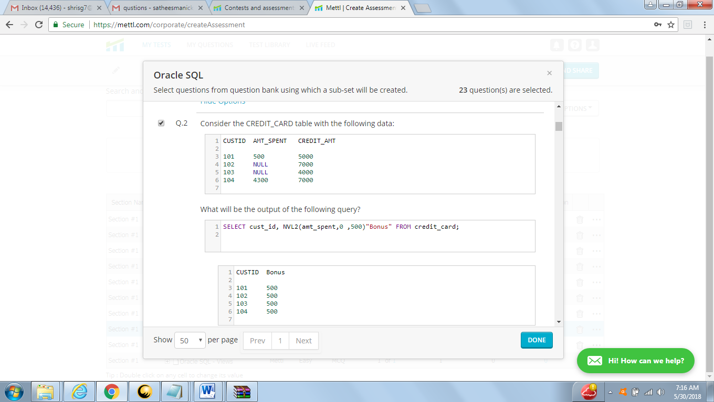

Answer

|  |  |
| --- | --- |
| **CUID** | **bonus** |
| 101 | 0 |
| 102 | 5000 |
| 103 | 5000 |
| 104 | 0 |

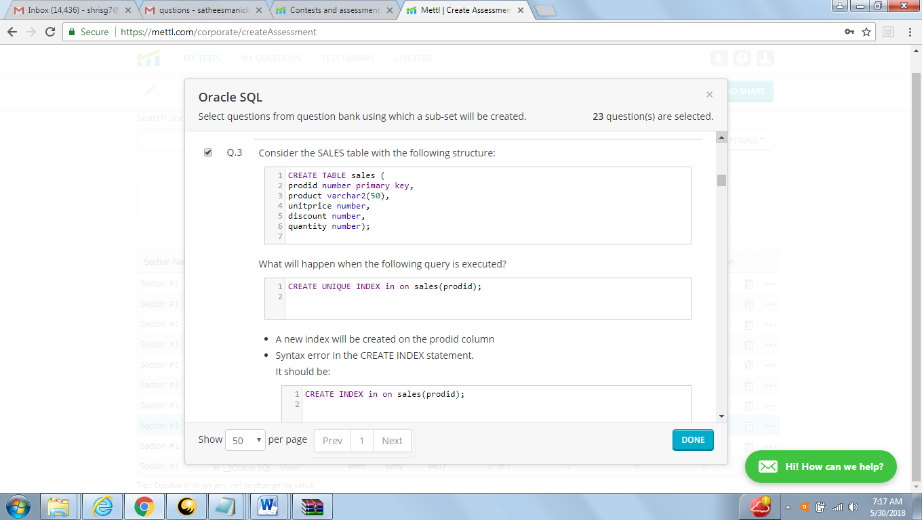

ANSWER

ORA-00953: missing or invalid index name

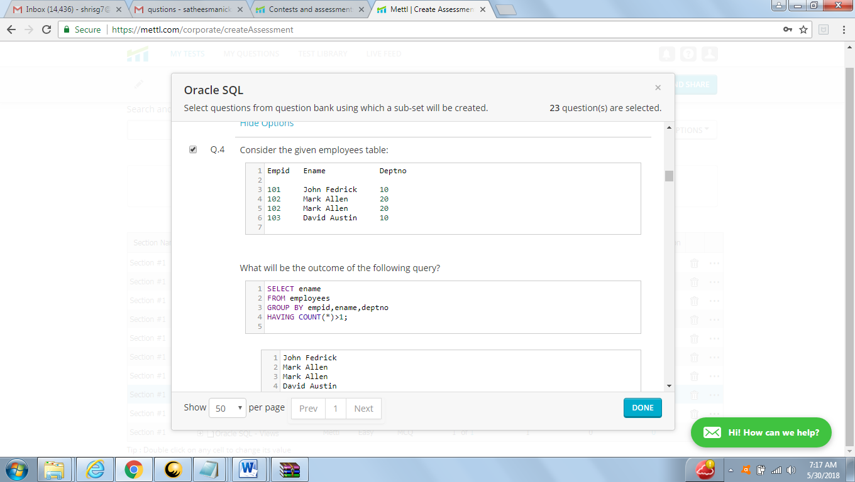

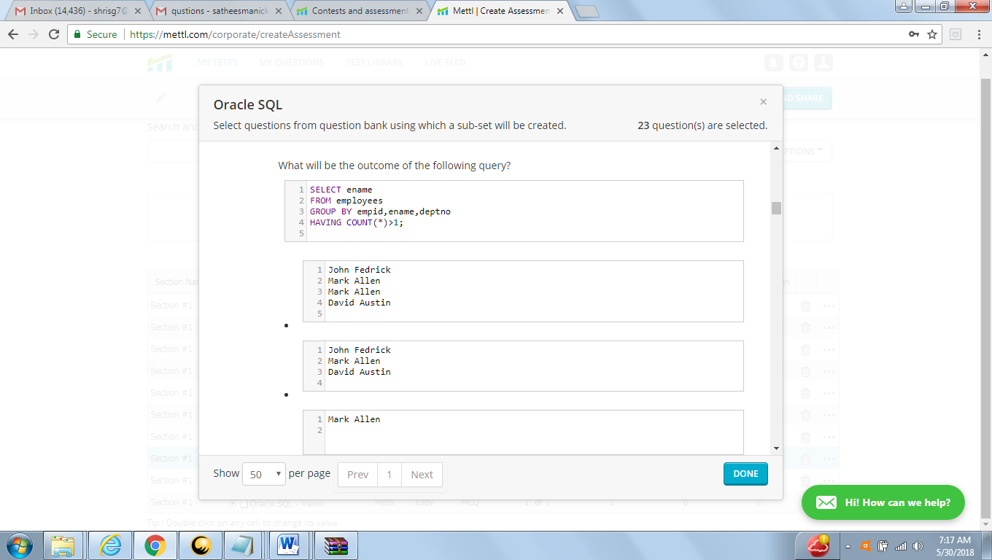

Answers : C (mark Allen)

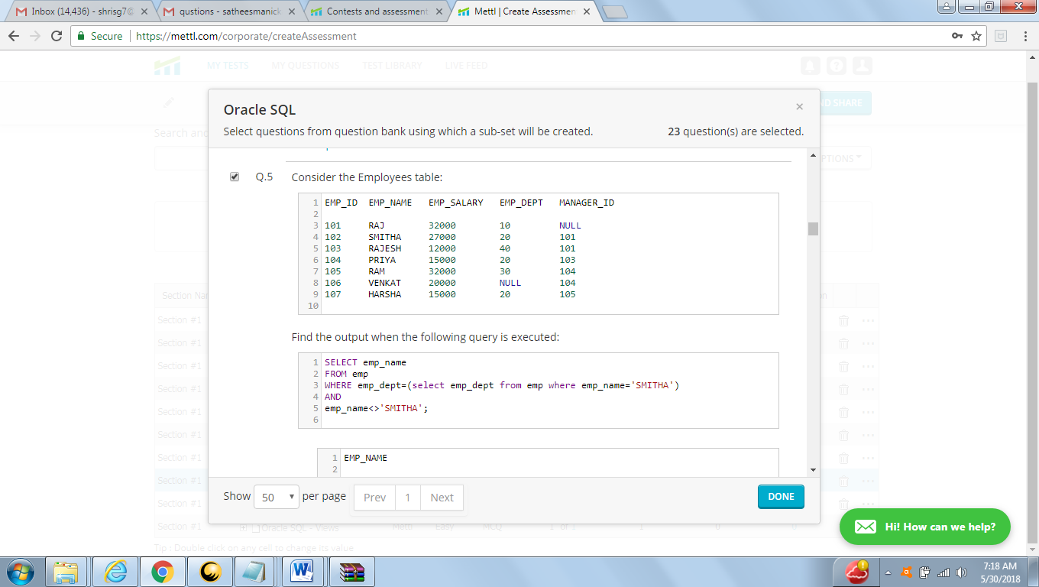

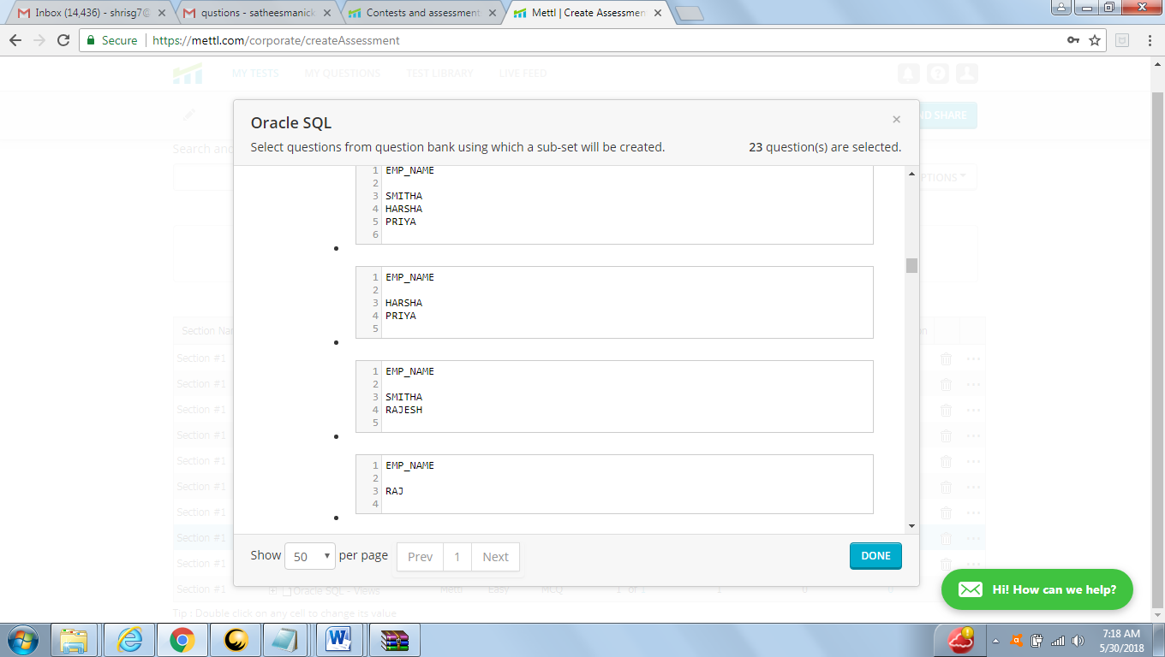

ANSWER :

|  |
| --- |
| **ENAME** |
| priya |

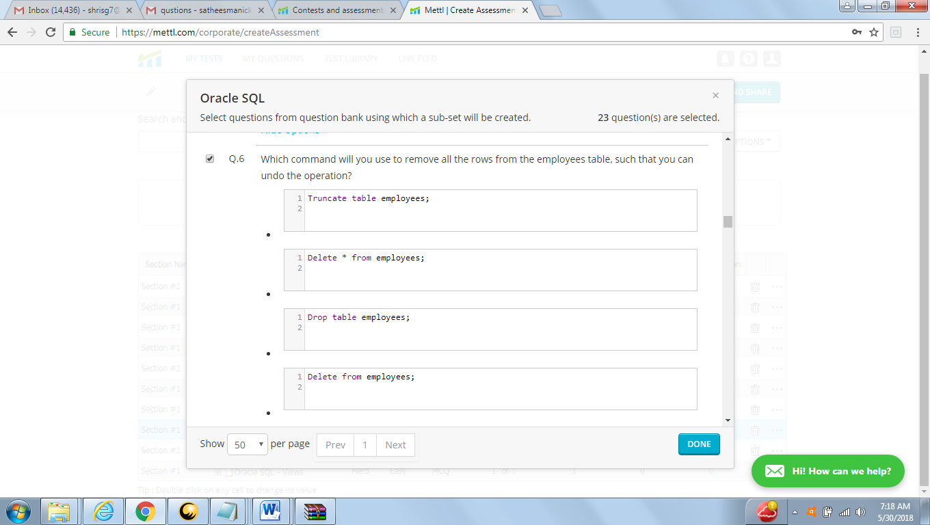

ANSWER : D

Delete from employee

|  |  |  |
| --- | --- | --- |
| **ROP** | **DELETE** | **TRUNCATE** |
| Drop Command is a DDL Command | DELETE Command is a DML Command | TRUNCATE Command is a DDL Command |
| It removes the whole table from the database | It removes all/ single/multiple rows from the table | It removes all the rows exist in the table |
| WHERE clause cannot be used with DROP command | WHERE clause can be used with DELETE command | WHERE clause cannot be used with TRUNCATE command |
| Rollback cannot be possible | Rollback can be possible | Rollback cannot be possible |
| Commit cannot be possible | Commit can be possible | Commit cannot be possible |
| No Trigger will be fired | Trigger will be fired | No Trigger will be fired |
| Faster and Time saving | Slowest and Time consuming | Faster and Time saving |
| **Syntax** DROP TABLE table_name; | **Syntax**  DELETE TABLE table_name; COMMIT; | **Syntax**  TRUNCATE TABLE table_name; |

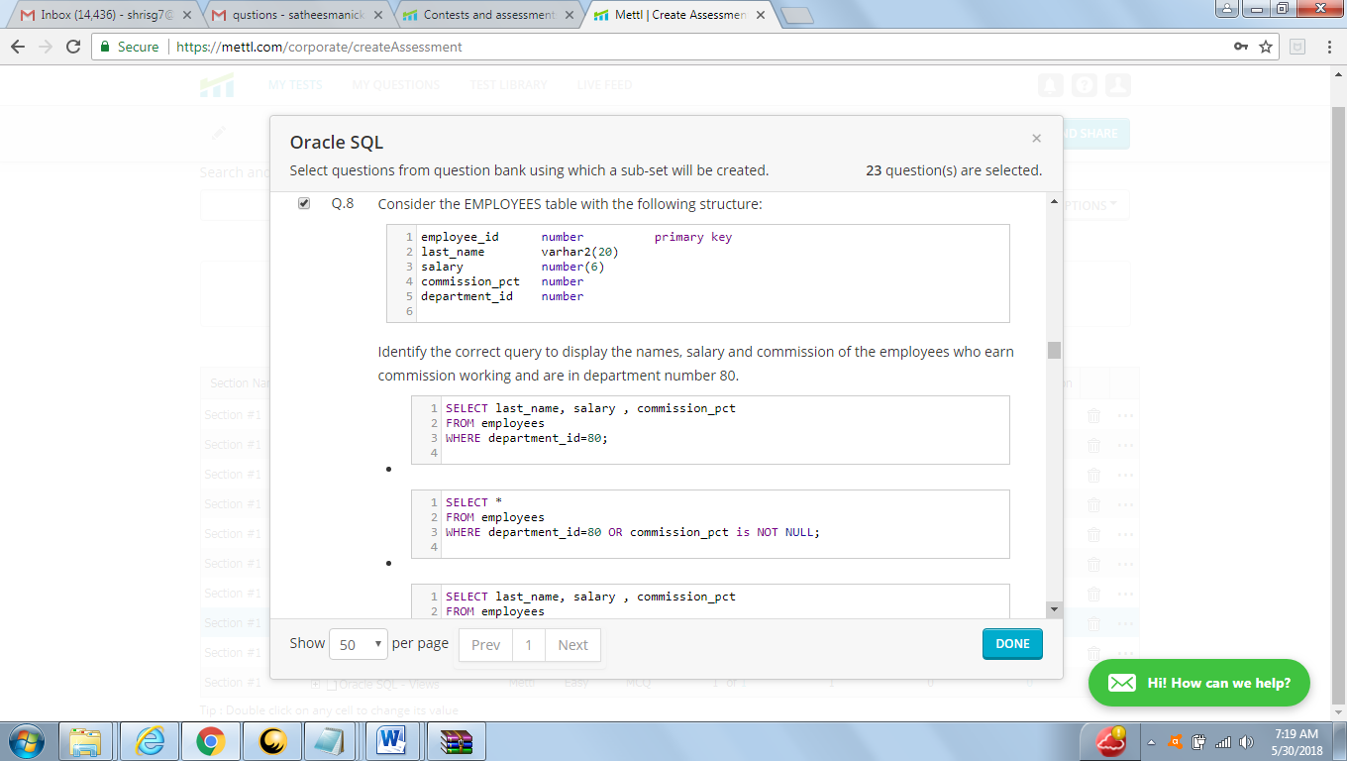

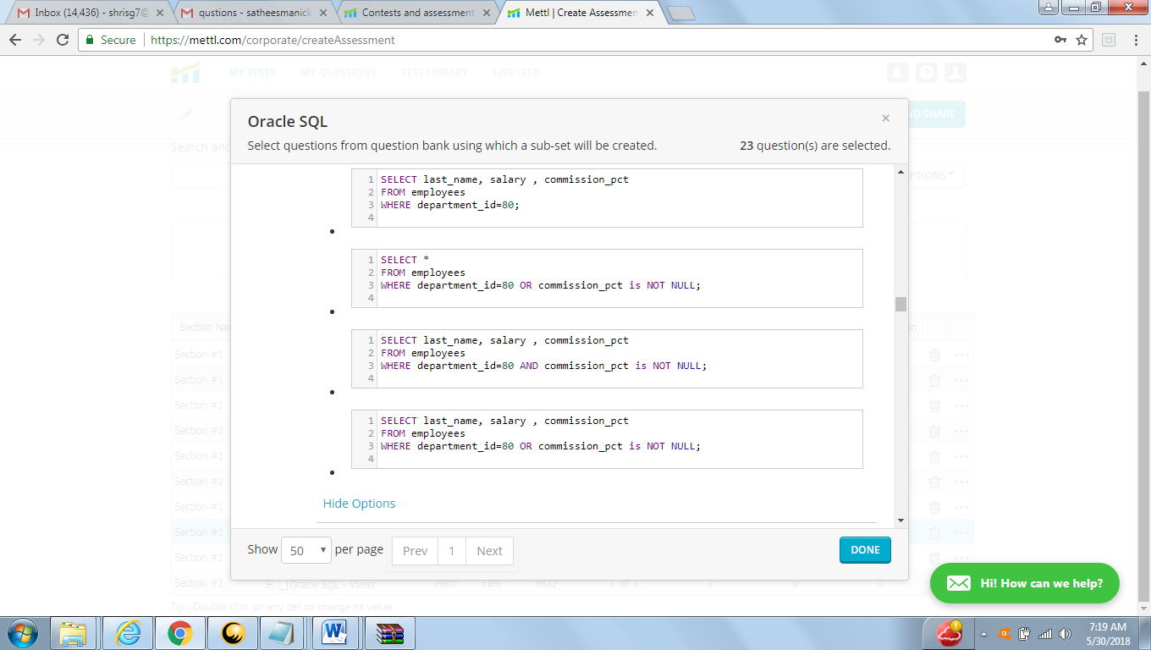

ANSWER : C

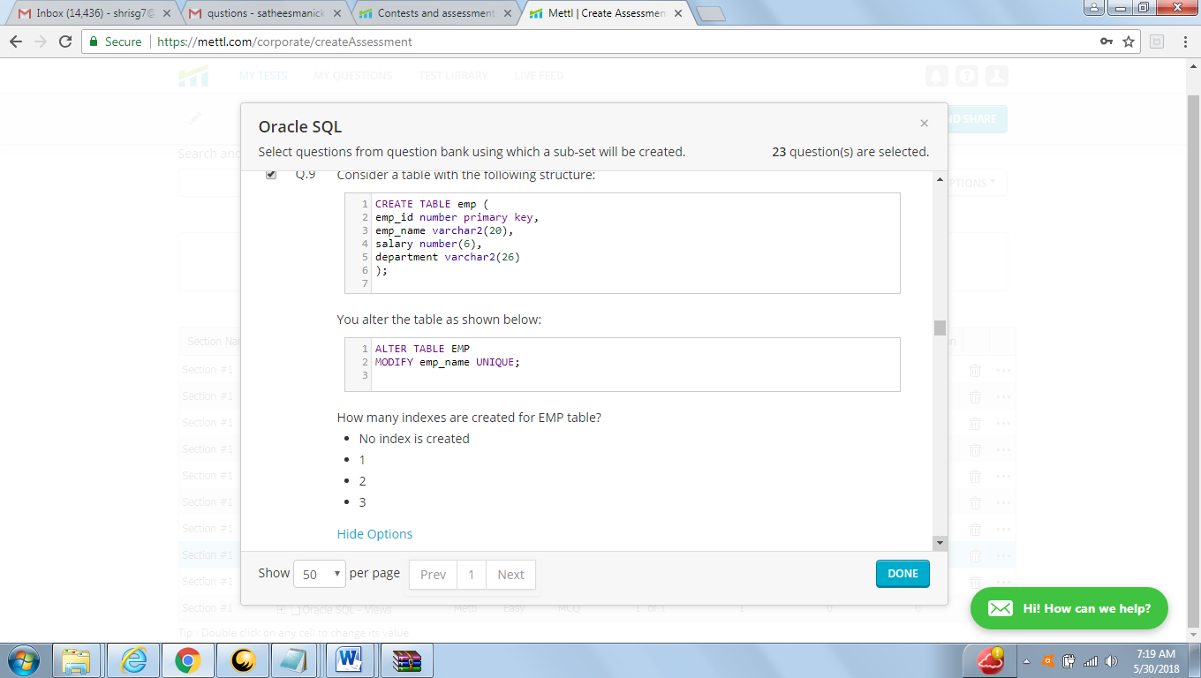

Answer :B

1. (index name EMP_NAME)

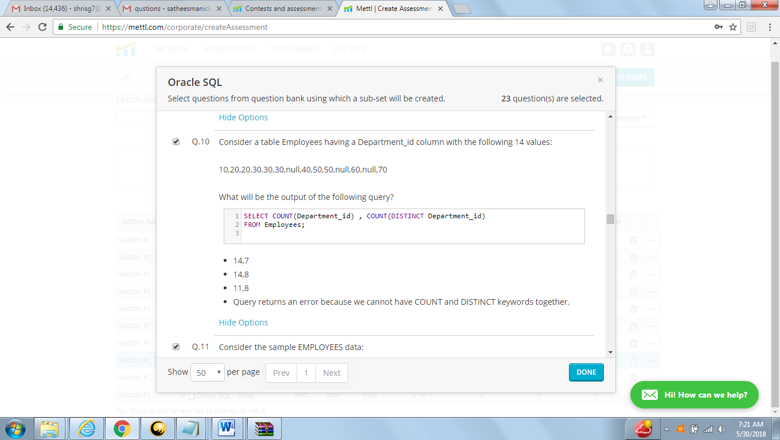

Answer A:

14,7

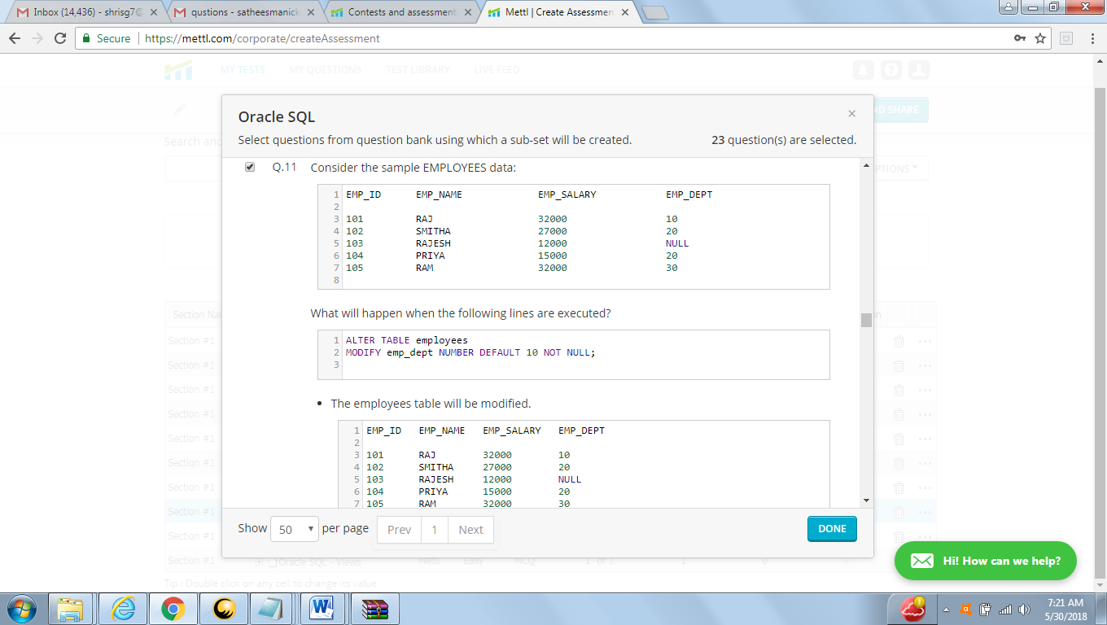

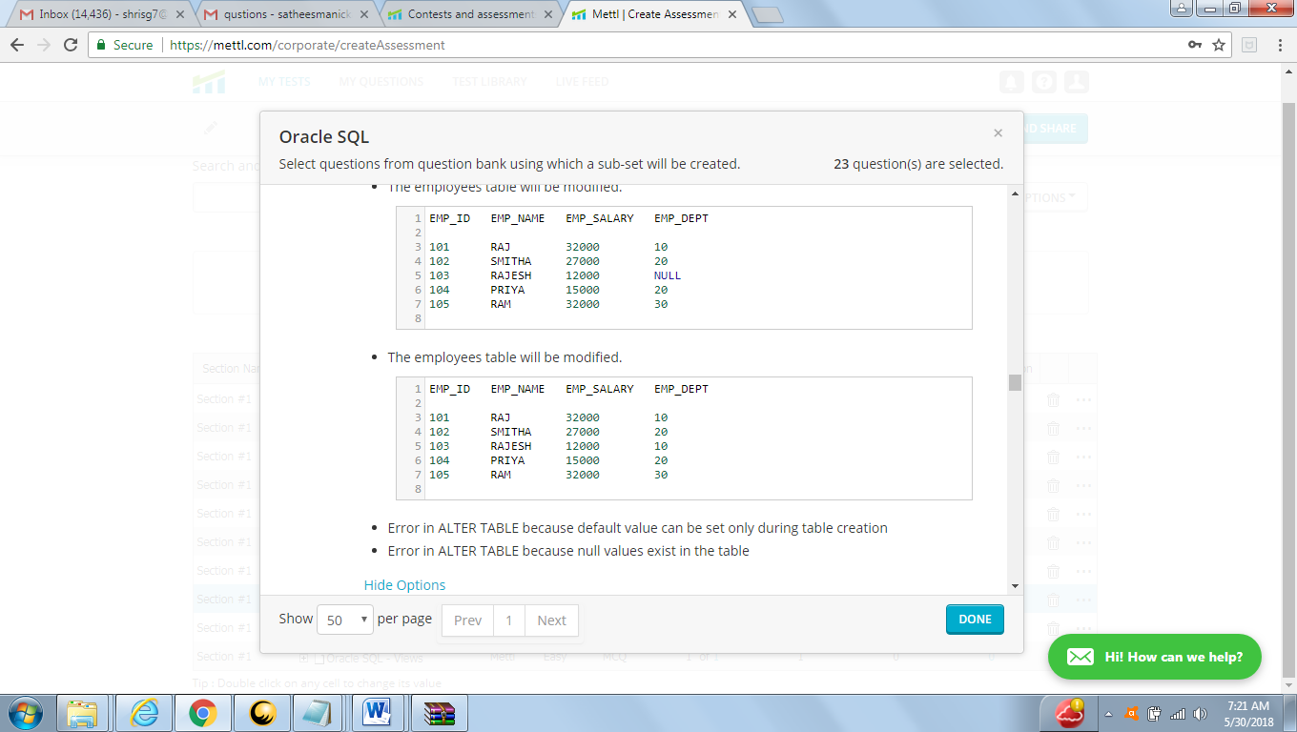

ANSWER: ORA-02296: cannot enable (SQL_CCBOUXVZJLXIYHUIDWRZOBPCH.) - null values found

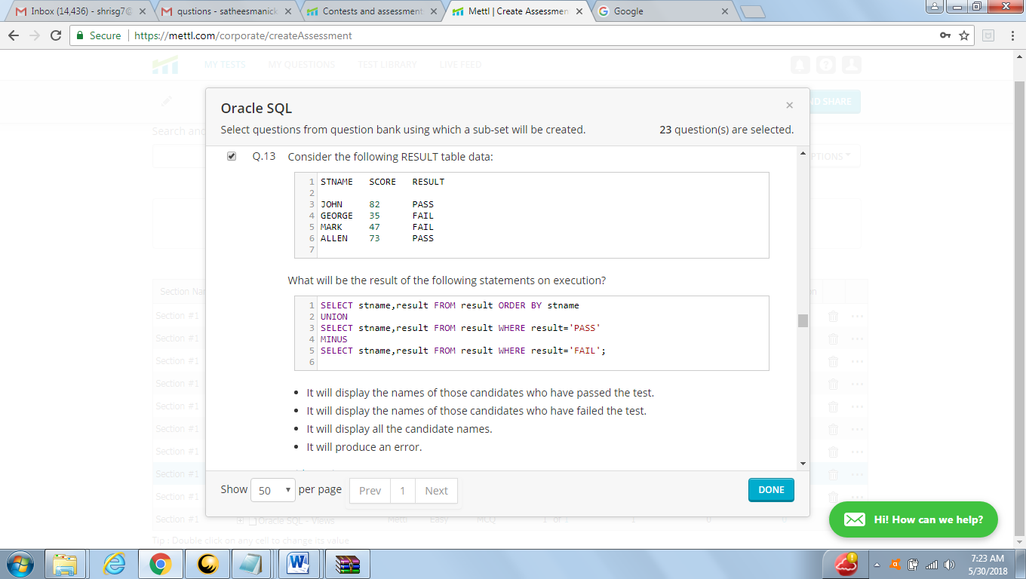

Answer : it display all the candidate name

|  |  |
| --- | --- |
| **SNAME** | **RESULT** |
| ALIN | PASS |
| MARK | FAIL |
| gorger | FAIL |
| johan | PASS |

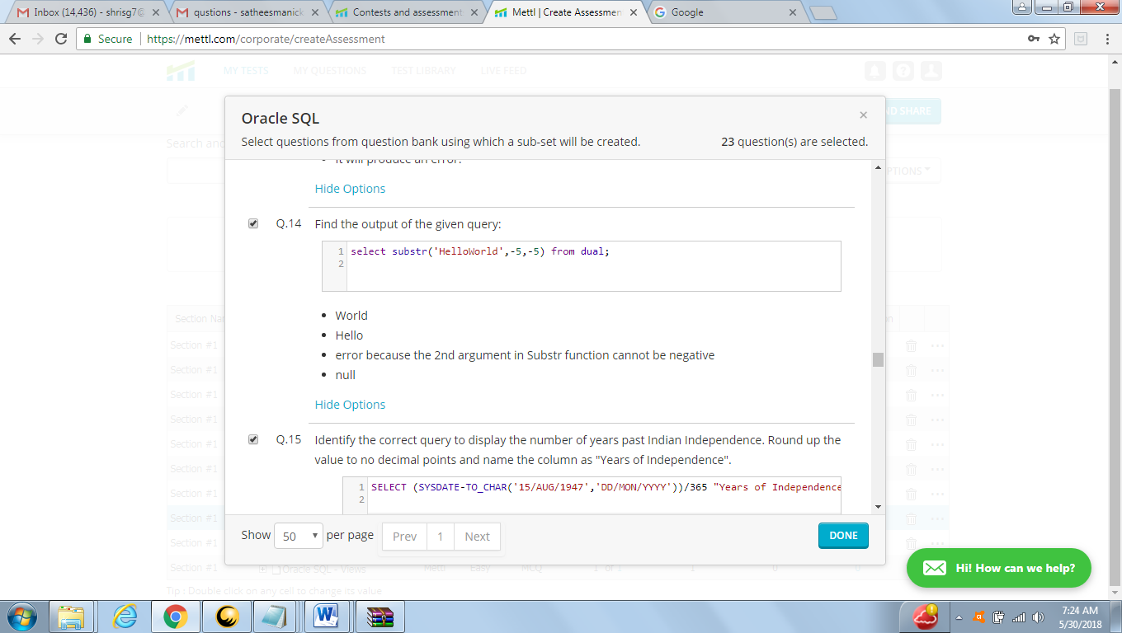

Answer : null

|  |
| --- |
| **SUBSTR('HELLOWORLD',-5,-5)** |
| - |

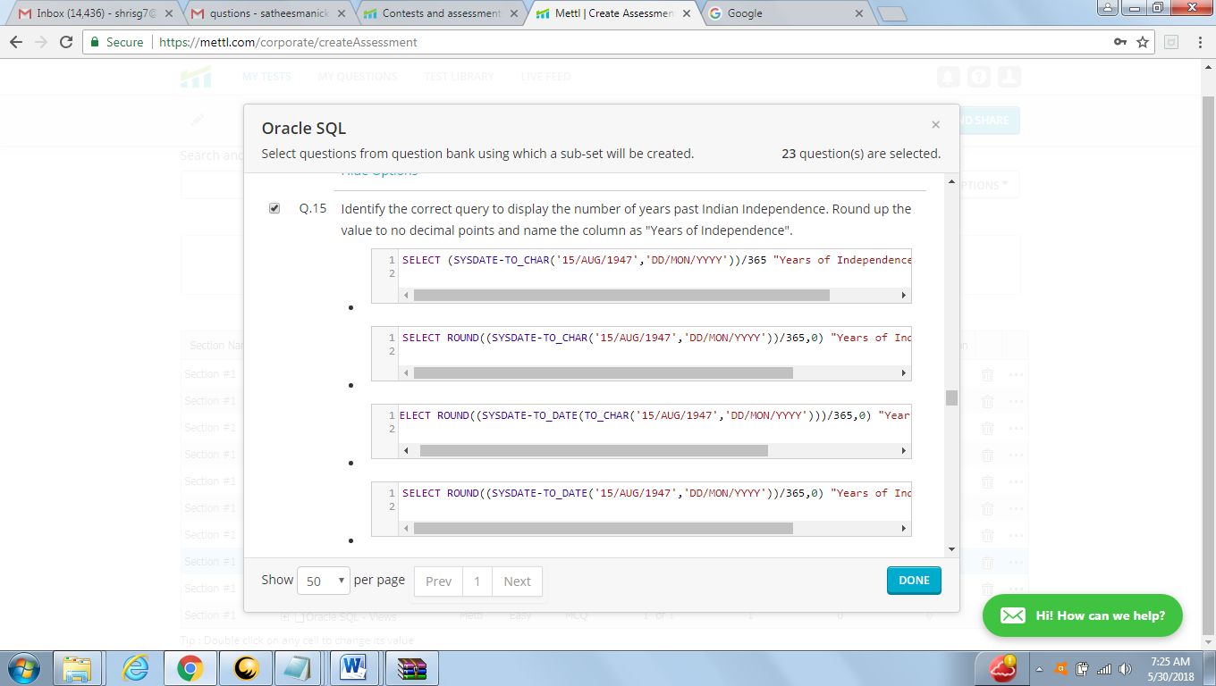

Answer : 2 option might be

select round(sysdate -to_date('15/AUG/1947','DD/MON/YYYY'))/365,0) 'year of indepenent' FROM dual ;

ORA-00923: FROM keyword not found where expected

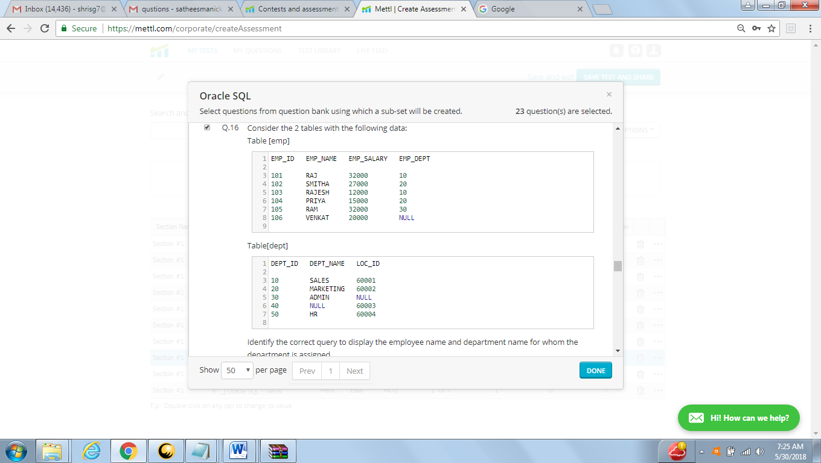

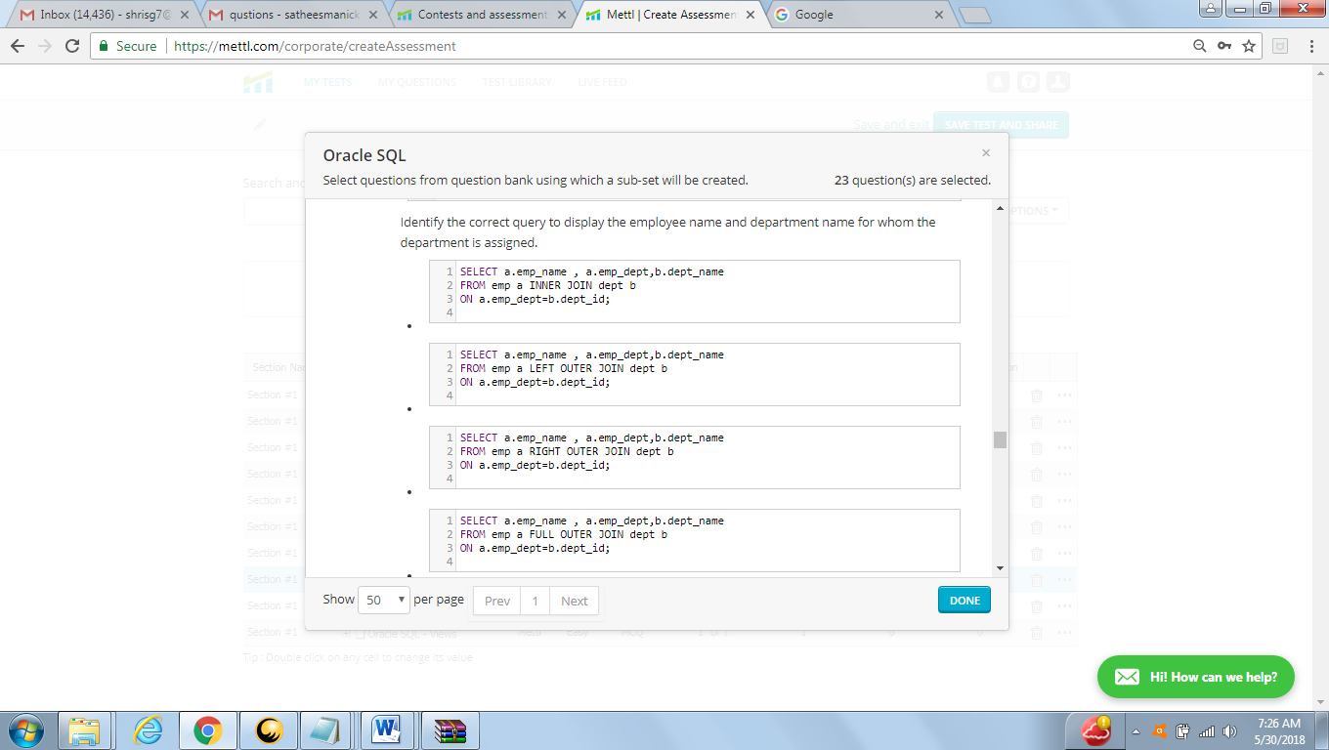

Answer: option A (first)

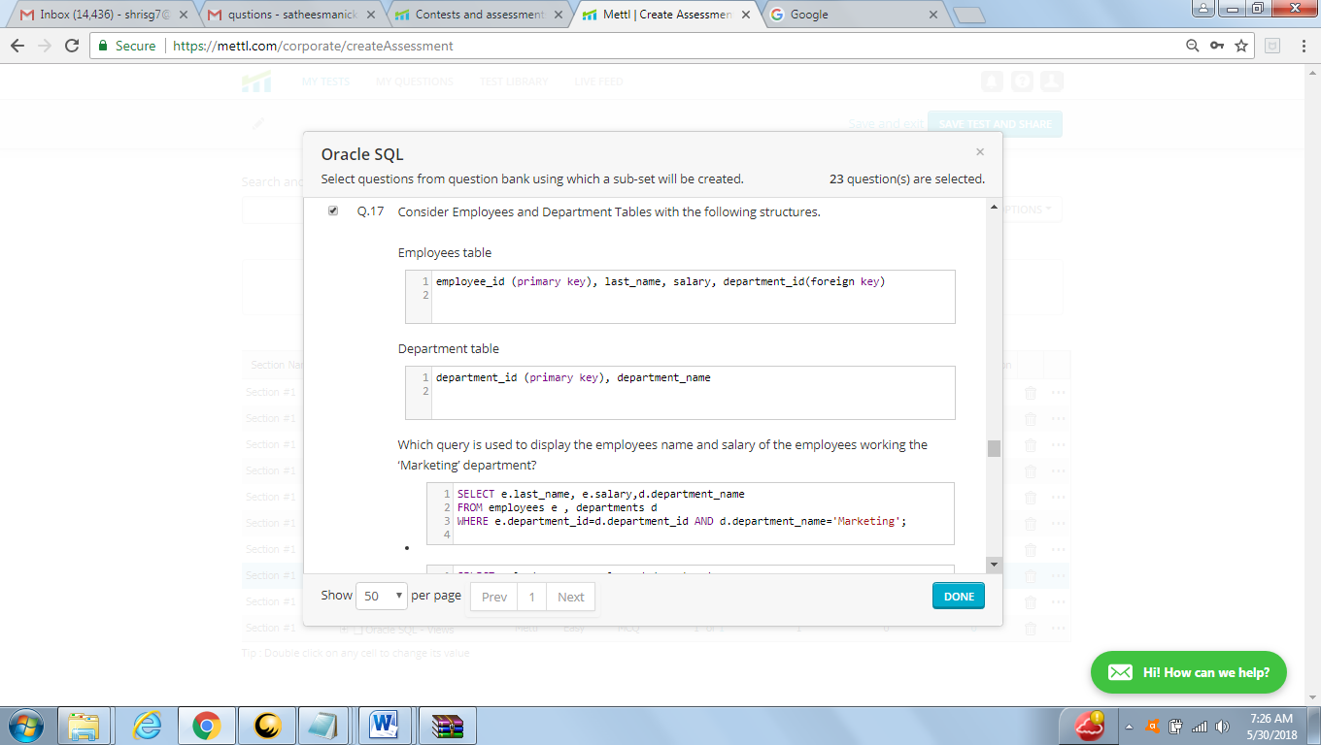

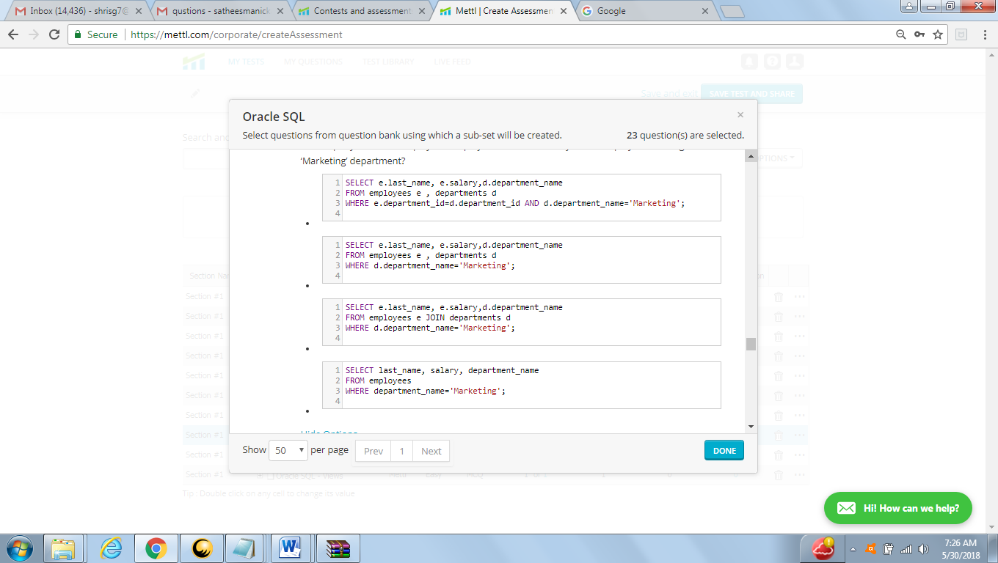

Answer : A

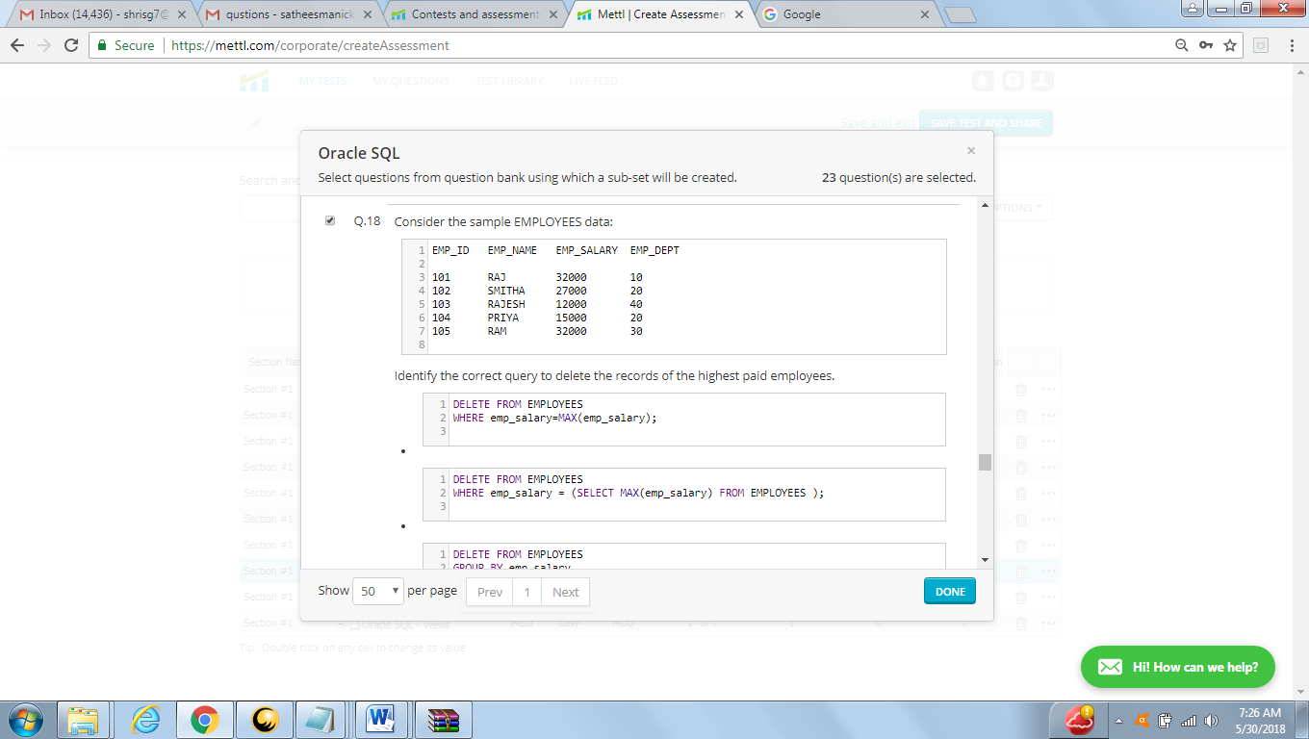

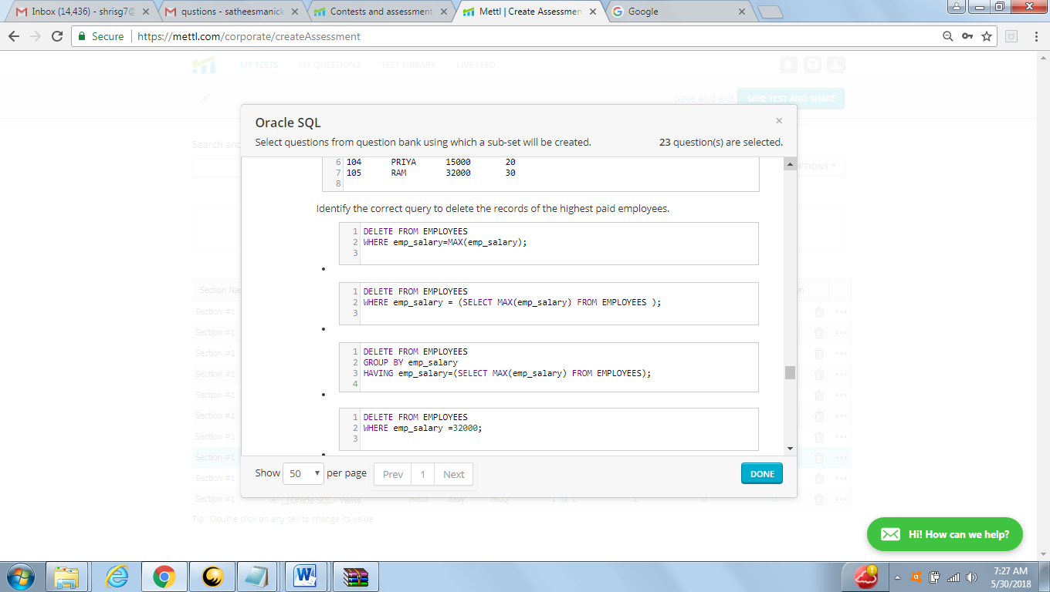

Answers : B

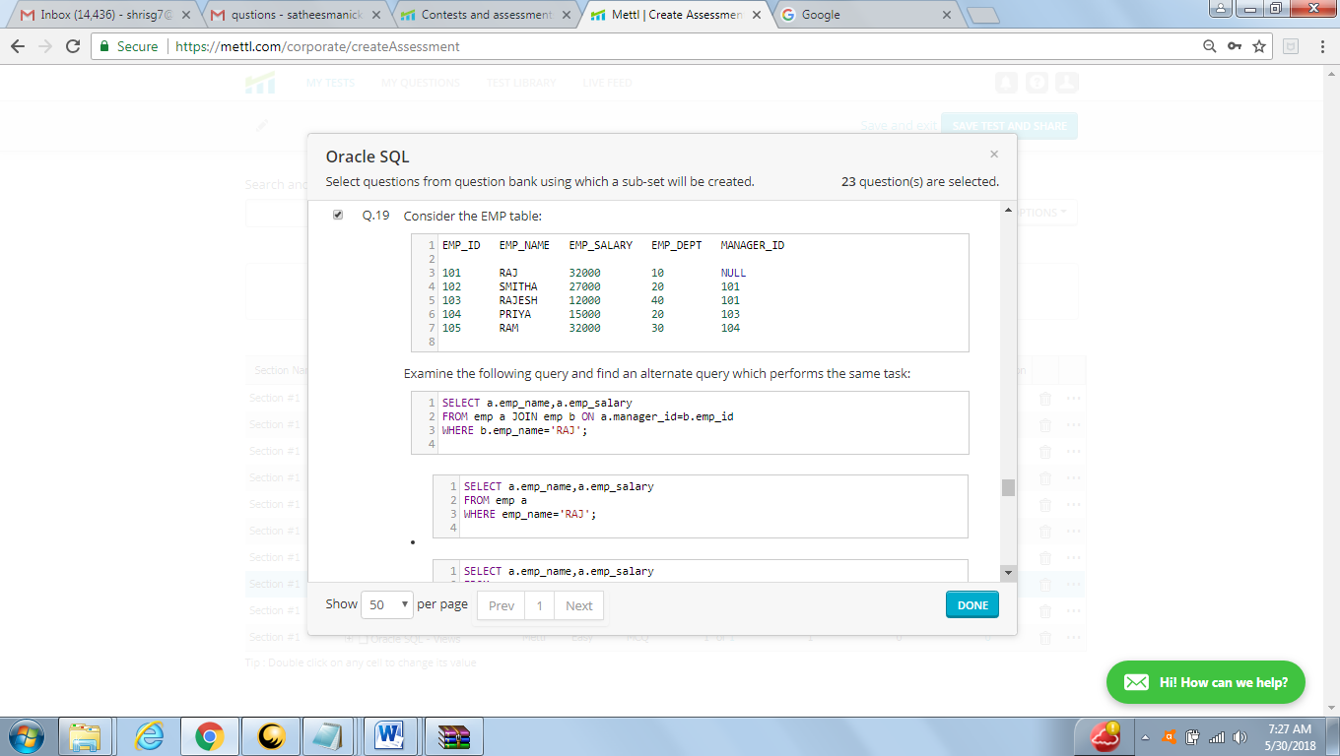

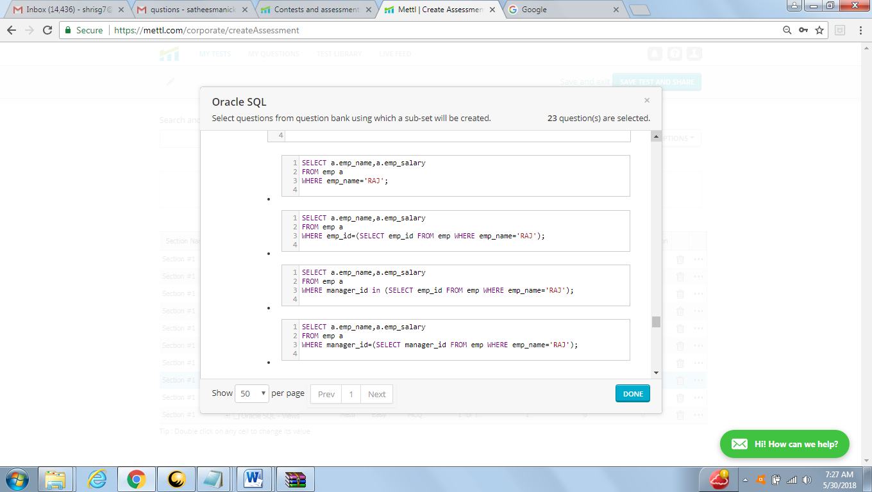

Answer : C

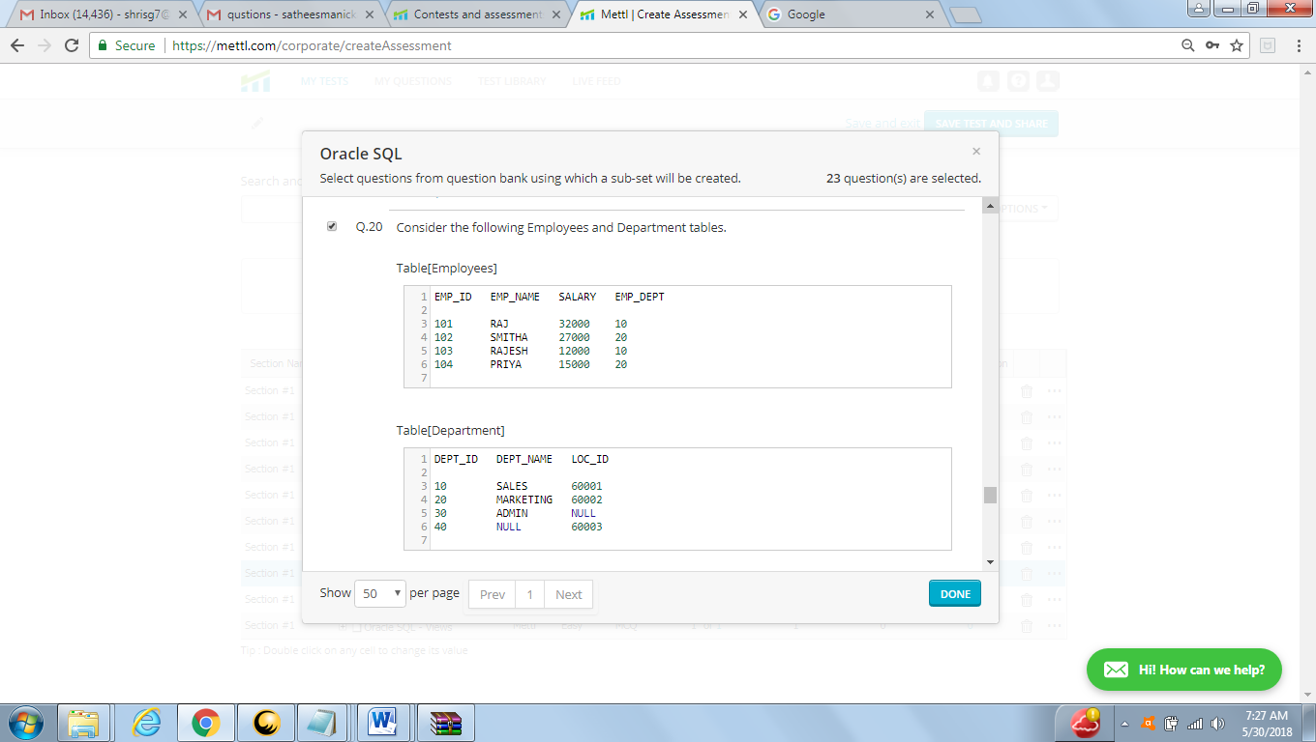

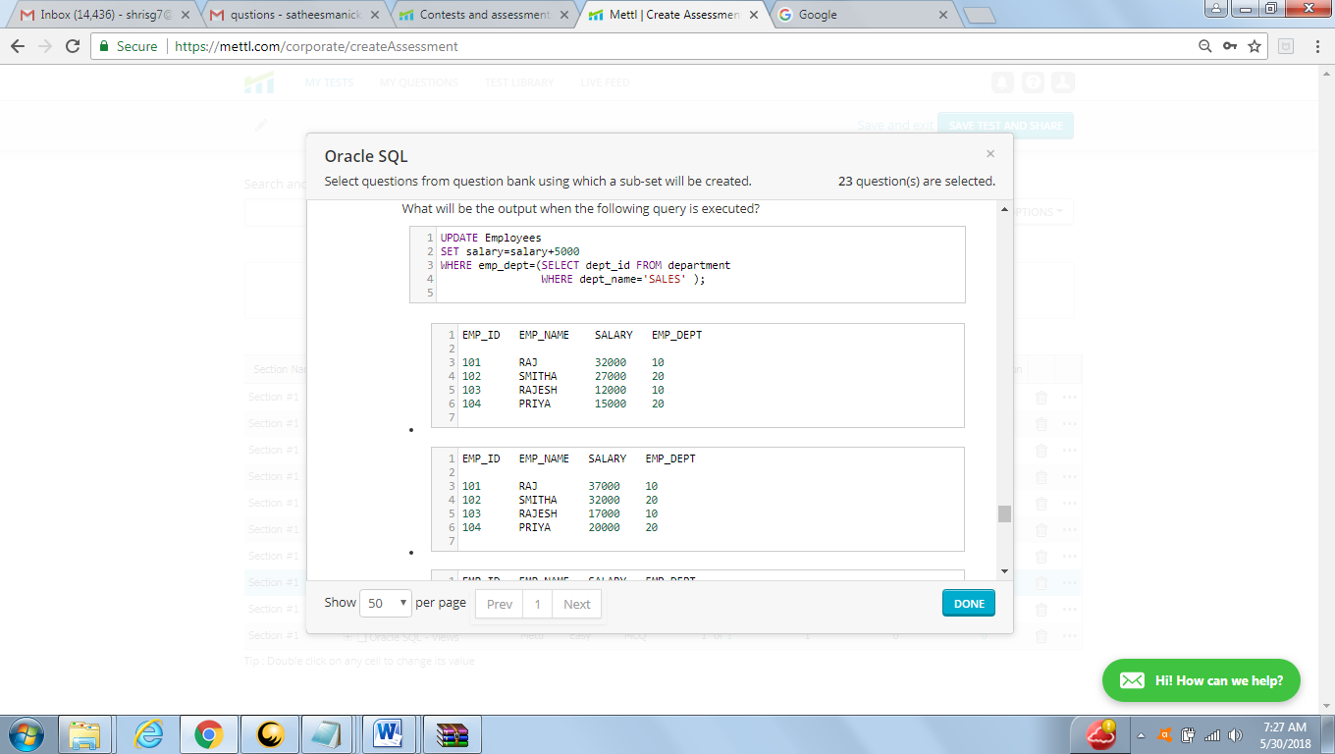

Answer : B

|  |  |  |  |
| --- | --- | --- | --- |
| **EMPNO** | **ENAME** | **SAL** | **DEPTNO** |
| 101 | raj | 37000 | 10 |
| 102 | smitha | 27000 | 20 |
| 103 | rajesh | 17000 | 10 |
| 104 | priya | 15000 | 20 |

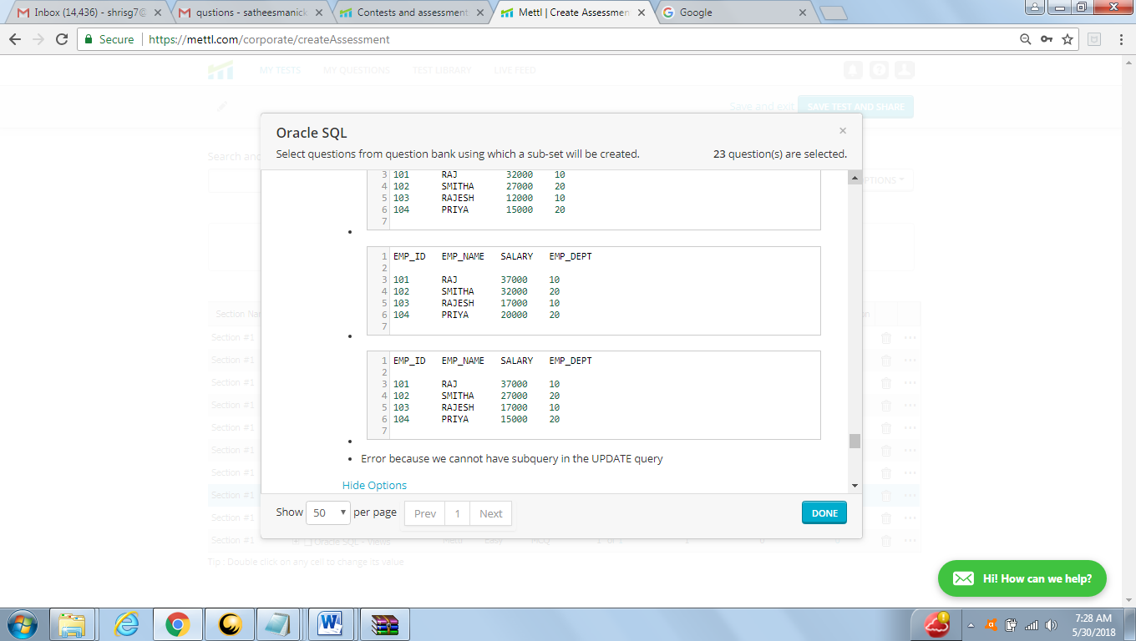

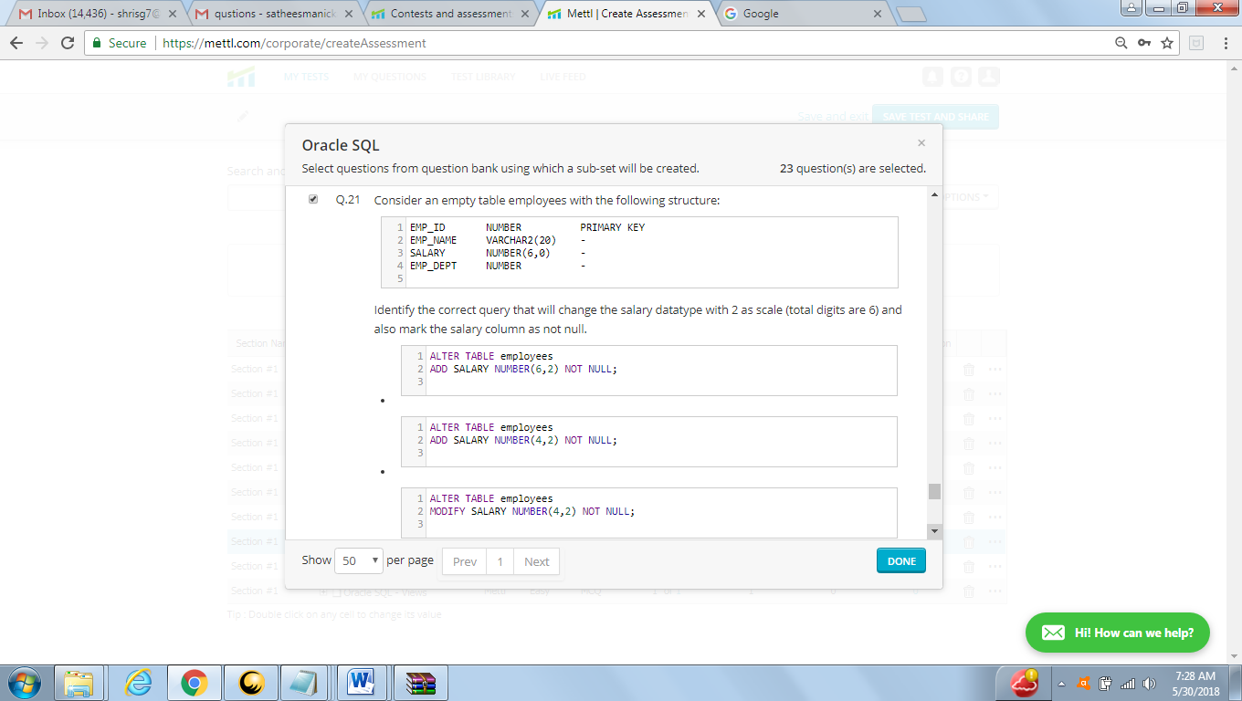

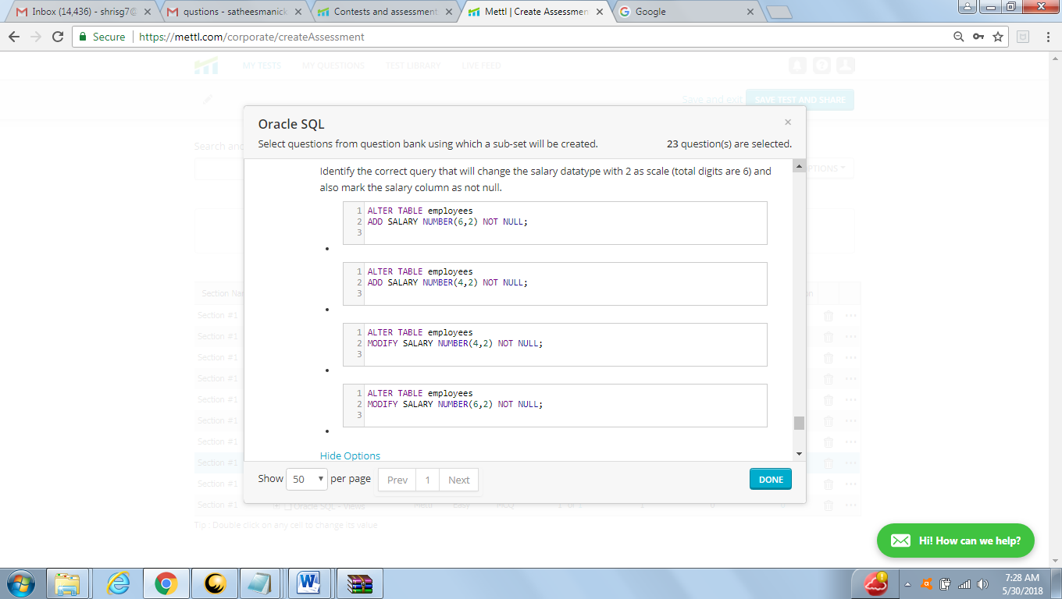

Answer : D

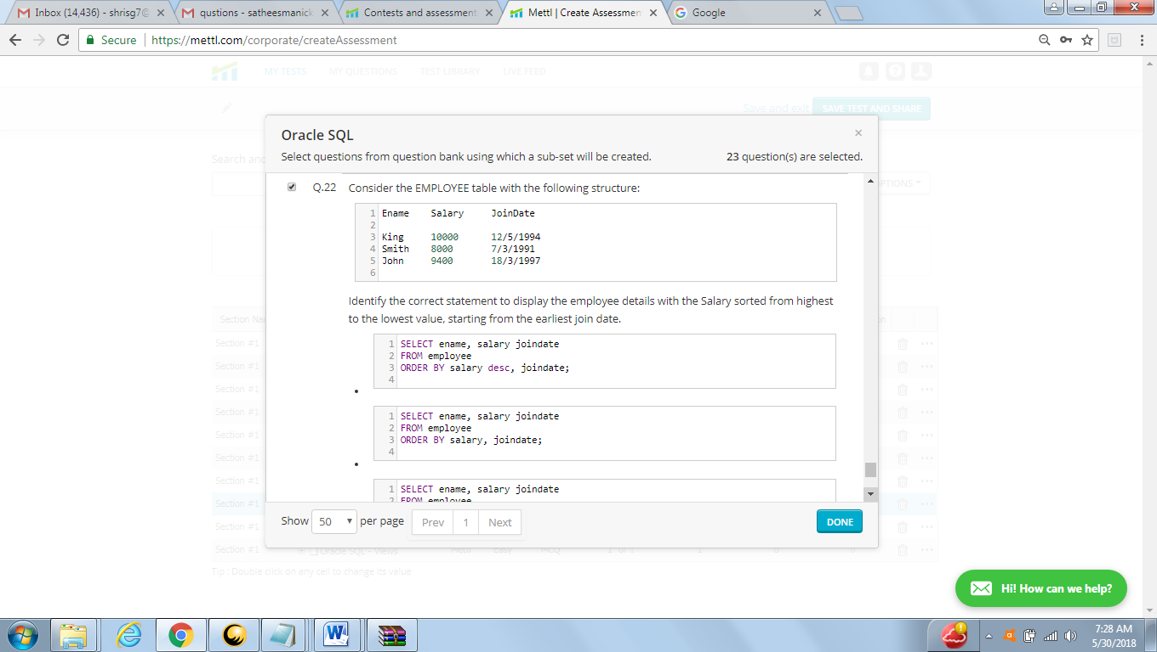

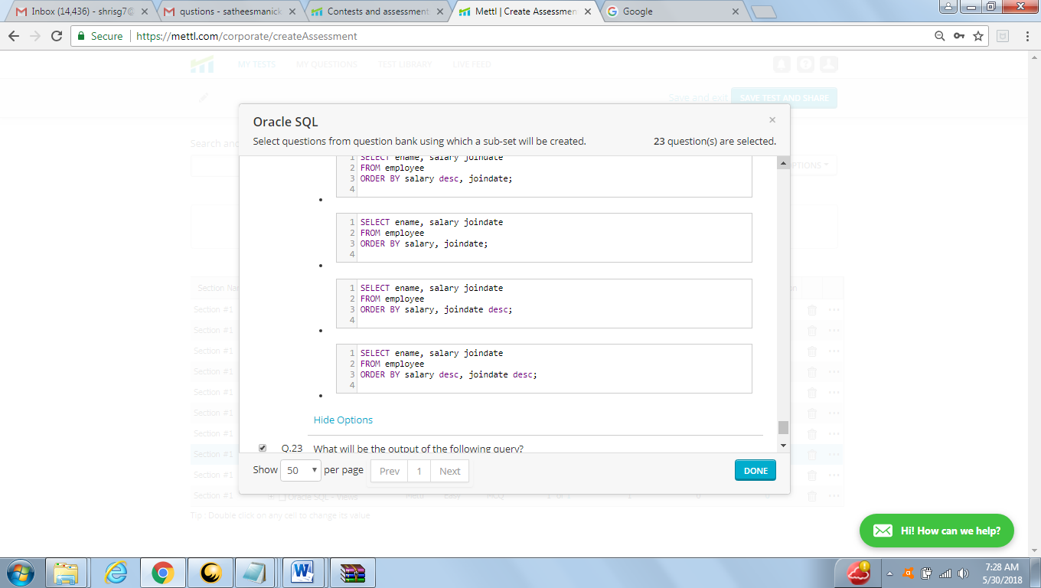

Answer : A

Difficult

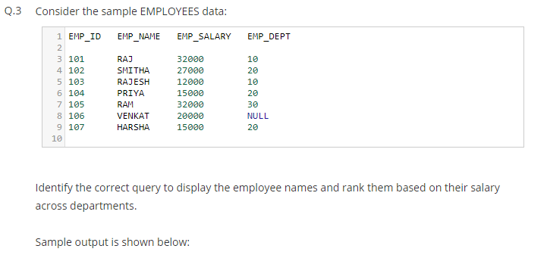

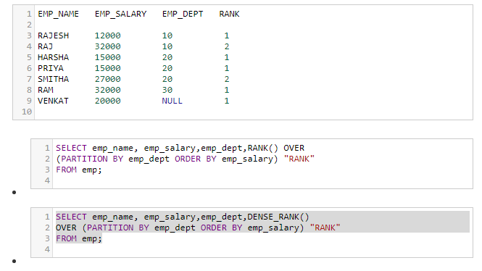

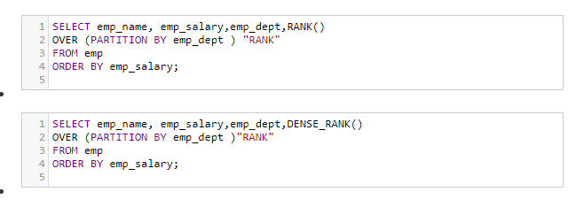

Answer : B

